**Name: Chitradevi Maruthavanan**

**Week -7 Video Activity**

**Activity 13.1 – Loop JOIN Basics**

**Page-oriented Nested Loops Join**

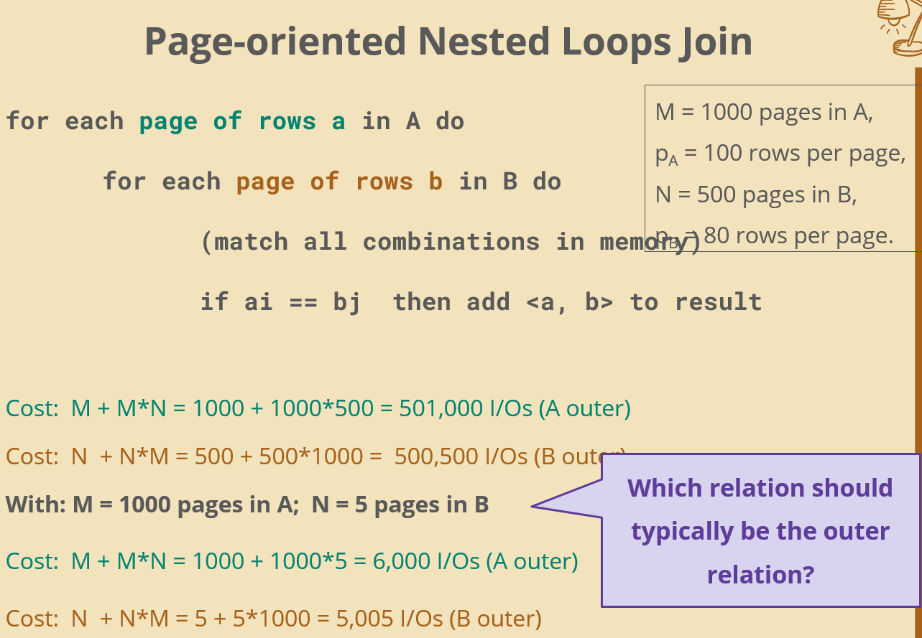

1. **Which relation should typically be the outer relation?**

Typically use smaller relation as outer relation

**M = 1000 pages in A; N = 500 pages in B**

I have 1000 pages in A and 500 pages would be the relations are close to the same size. It is slightly faster.

**M = 1000 pages in A; N = 5 pages in B**

B is much smaller. And in this case, we get costs are 6,000 (A outer) and 5,0051

(B Outer).So typically we want the smaller relation as the outer relation.

**Activity 14.1 – Sort-Merge JOIN**

1. **What does disk-based sort mean?**

Disk based sort means that the relation or the table or the file what we have that we are sorting doesn’t fit in the memory. I have to use sort algorithms such as sorting algorithms, bubble sort, etc..Disk based sort means that I can't read the whole file in memory at once. I have to sort the file in pieces.

1. **Why do you have to sort on the join attribute?**

Both relations were sorted on the join attribute, then only we can do this sort of merge between the two relations. If both relations were not, they were not sorted on the join attributes.

**Activity 14.2 – External Merge-Sort**

1. **What is an “external sorting algorithm”?**

External sorting algorithm is an algorithm that works when the file is to be sorted, relation file, data doesn't fit in the main memory. So, the buffer pool is allocated to the sort. If you think about your traditional sort algorithms, right there always expressed as these manipulations and they don't take into an account whether where that data resides, grade those sorting algorithms.